**8. Stochastic POS Tagging**

**Aim:**  
To implement a basic stochastic POS tagging algorithm.

**Algorithm:**

1. Collect tagged data from a corpus (e.g., Brown Corpus).
2. Train a model using word-tag probabilities.
3. Tag an input sentence using the probabilistic model.

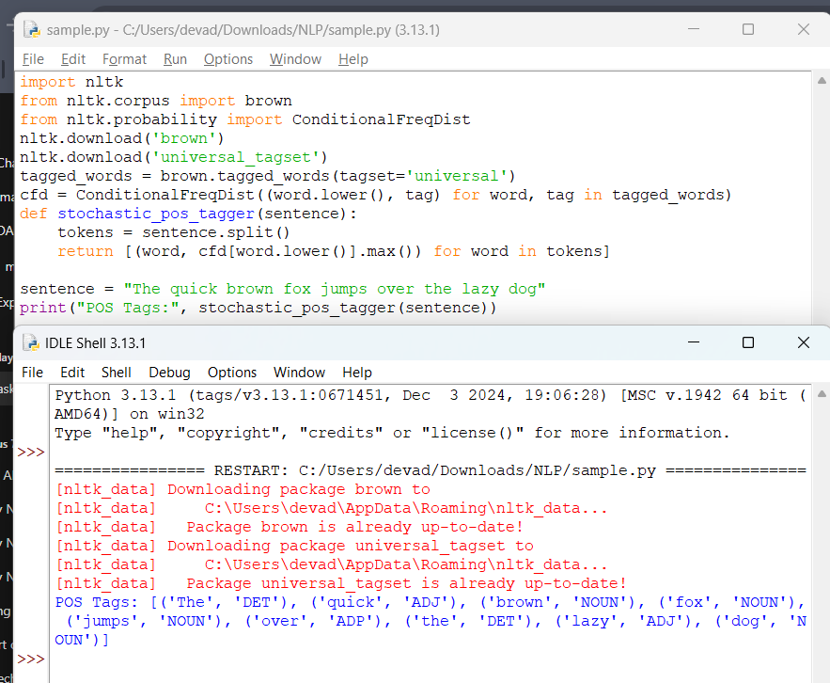

**Result:**  
The program tags words probabilistically.